PROJECT-35
MEETING SCHEDULER

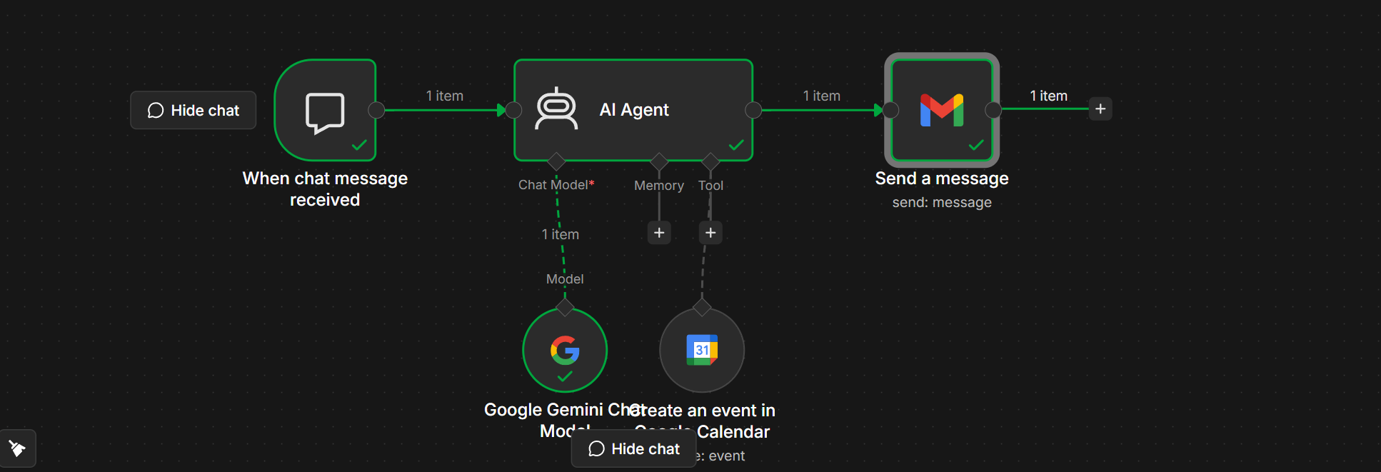
AI Meeting Scheduler with Google Calendar and Gmail using n8n

Objective
Build an AI-powered meeting scheduler that accepts meeting requests through chat, creates a Google Calendar event, and sends a meeting invitation email automatically.

Workflow Overview
User Chat
│
▼
When Chat Message Received
│
▼
AI Agent
│
├──────────────► Google Gemini Chat Model
│
└──────────────► Google Calendar Tool
│
▼
Send Gmail Message
│
▼
Meeting Invitation Sent

Nodes Used
Step | Node | Purpose
1 | When Chat Message Received | Starts the workflow when a user sends a chat message
2 | AI Agent | Understands the meeting request and extracts details
3 | Google Gemini Chat Model | Generates AI responses
4 | Google Calendar Tool | Creates a meeting event
5 | Gmail | Sends a meeting invitation email

Step 1: When Chat Message Received
Purpose
Starts the workflow whenever a user sends a message.
Example User Input
Schedule a meeting with Rahul tomorrow at 2 PM for one hour.

Email: rahul@gmail.com
Output is sent to the AI Agent.

Step 2: AI Agent
Purpose
The AI Agent understands the user's request and determines when to use the Google Calendar tool.
Prompt (User Message)
You are an AI Meeting Scheduler.

Your job is to:

• Schedule meetings

• Create Google Calendar events

• Send meeting invitation emails

If the user does not provide:

- Meeting title
- Date
- Time
- Duration
- Recipient email

Ask for the missing information.

Once everything is available:

1. Use the Google Calendar tool.
2. Confirm the meeting has been created.

System Message
You are a professional AI assistant.

Always use the Google Calendar tool whenever the user asks to schedule a meeting.

Never say the meeting is scheduled unless the calendar event is successfully created.

Be polite and professional.

Step 3: Google Gemini Chat Model
Purpose
Processes natural language and helps the AI Agent understand meeting requests.
Configuration
Setting | Value
Model | Gemini 2.5 Flash
Temperature | 0.2
Max Tokens | Default

Step 4: Google Calendar Tool
Purpose
Creates a meeting event in Google Calendar.
Configuration
Field | Value
Credential | Google Calendar Account
Resource | Event
Operation | Create
Calendar | Primary Calendar

AI Fields
Calendar Field | From AI Description
Summary | Meeting title
Start | Meeting start date and time
End | Meeting end date and time
Description | Meeting description
Attendees | Recipient email

Example Event
Field | Value
Title | Project Review
Date | 10-Aug-2026
Time | 2:00 PM
Duration | 1 Hour
Guest | rahul@gmail.com

Step 5: Gmail Node
Purpose
Sends a meeting invitation email after the calendar event is created.
Configuration
Field | Value
Resource | Message
Operation | Send

To
rahul@gmail.com

Subject
Meeting Invitation - Project Review

Message
Hello Rahul,

You are invited to the following meeting.

Meeting Title: Project Review

Date: 10-Aug-2026

Time: 2:00 PM

Duration: 1 Hour

The meeting has been scheduled successfully.

Thank you for your time.

Best Regards,

AI Meeting Scheduler

Complete Workflow
User

↓

When Chat Message Received

↓

AI Agent

↓

Google Gemini Chat Model

↓

Google Calendar
(Create Event)

↓

Gmail
(Send Invitation)

↓

Meeting Scheduled Successfully

Example Conversation
User
Schedule a project review meeting tomorrow at 2 PM with Rahul.

Email: rahul@gmail.com

AI Agent
- Extracts the meeting title.
- Identifies the date and time.
- Calculates the end time.
- Calls the Google Calendar tool.

Google Calendar
Creates:
Project Review

10-Aug-2026

2:00 PM - 3:00 PM

Gmail
Sends:
Subject
Meeting Invitation - Project Review
Body
Hello Rahul,

You are invited to attend the following meeting.

Meeting Title: Project Review

Date: 10-Aug-2026

Time: 2:00 PM

Duration: 1 Hour

Please attend the meeting on time.

Best Regards,

AI Meeting Scheduler

Expected Output
- ✅ User sends a meeting request.
- ✅ AI Agent understands the request.
- ✅ Google Calendar creates the event.
- ✅ Gmail sends a professional invitation email.
- ✅ User receives a confirmation that the meeting has been scheduled.

Learning Outcomes
After completing this workflow, you will be able to:
- Build an AI-powered meeting scheduler in n8n.
- Use an AI Agent with the Google Gemini Chat Model.
- Create Google Calendar events automatically.
- Send personalized meeting invitation emails using Gmail.
- Build conversational AI workflows that automate real-world business tasks.

